UNIVERSITY OF RWANDA
RMA_GAKO CAMPUS
COLLEDGE OF SCIENCE AND TECHNOLOGY
COMPUTER ENGINEERING YEAR 3
MODULE: MOBILE DEVELOPMENT
ASSIGNMENT:UI_DESIGN
DATE:14/02/2026
GROUP 3
REGISTRATION NUMBERS:
- 223026673
- 223026513
- 223026695

1. INTRODUCTION
This document provides a comprehensive explanation of all Flutter widgets used in the Login UI design for Lab 3. Each widget is explained with:
- Code screenshot reference showing where the widget is used
- Visual impact on the UI
The UI implements a clean, modern login screen with the following elements:
- Header: "Login page" title with decorative gradient line
- Welcome Message: "Welcome" text
- Form Fields: Username and password input fields with icons
- Action Button: Right-aligned "Login" button with gradient
All widgets are implemented following Flutter best practices with proper spacing, alignment, and styling. No interactivity or state management is included as per lab requirements (pure UI design only).
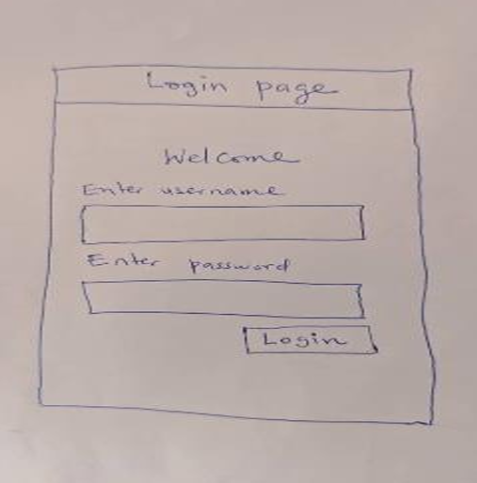
This was the work we were supposed to deal on , so we tried to create the ui design the looks like it
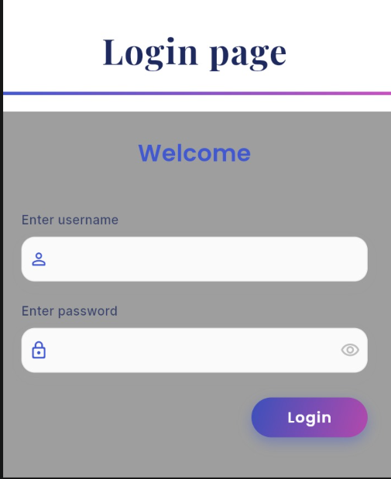

So let us go to the widgets used while designing this UI

MATERIALAPP WIDGET
MaterialApp is the foundation widget that every Flutter app must have. It configures core app properties like the title, theme, and home screen. Without it, Material Design widgets like Scaffold won't work properly. It also manages navigation, localization, and accessibility features.
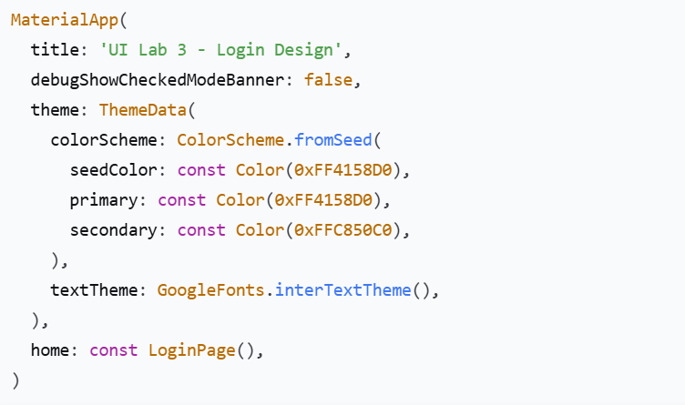

2. SCAFFOLD WIDGET
Scaffold is the structural backbone of each screen. It implements the basic Material Design layout, providing a framework for app bars, drawers, bottom sheets, and the main content area. It ensures proper positioning of UI elements.
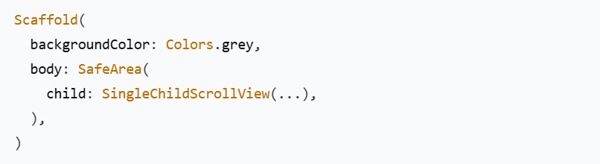

3. COLUMN WIDGET
Column is the primary layout widget for vertical arrangements. It places each child widget below the previous one, creating a natural top-to-bottom flow. This is essential for forms and lists.
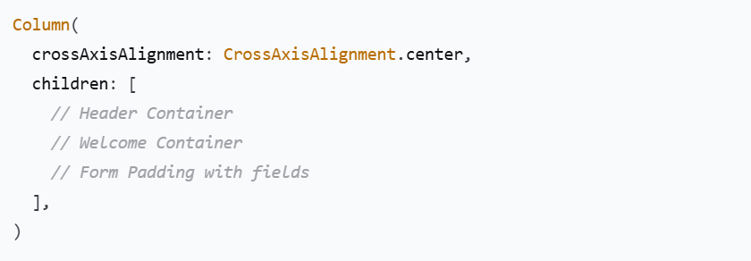

4. CONTAINER WIDGET
Container is the most versatile widget in Flutter. It combines painting, positioning, and sizing capabilities. It can have background colors, borders, shadows, padding, margins, and can be transformed.
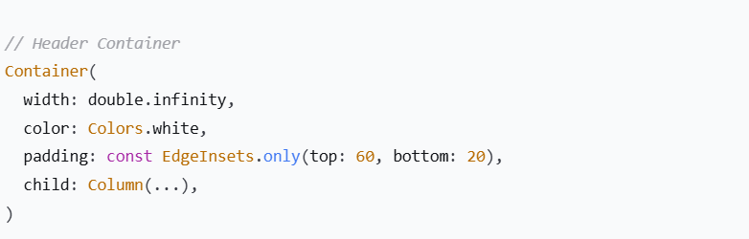

5. TEXT WIDGET
Text is the fundamental communication widget that displays all written content. It can be extensively styled with different fonts, sizes, weights, colors, and spacing to create visual hierarchy.
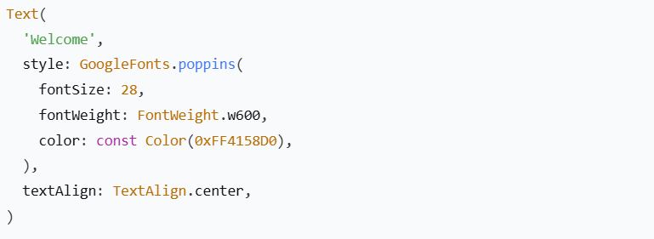

6. TEXTFIELD WIDGET
TextField is the essential input widget that allows users to enter text. It provides keyboard management, input validation, and extensive styling options. For login forms, it's the primary way users provide their credentials.
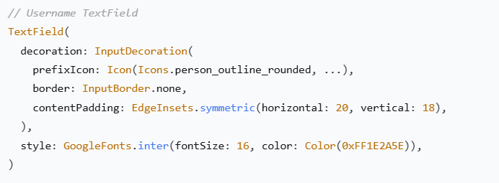

7. ICON WIDGET
Icons provide visual communication that supplements text labels. They help users quickly understand the purpose of each field without reading labels. Icons are universal and cross language barriers.
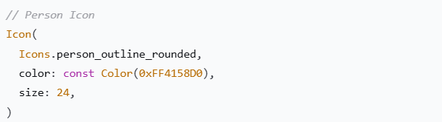

9. ALIGN WIDGET
Align is a positioning widget that places its child at a specified location within the available space. It's essential for creating balanced layouts where elements need specific alignment.
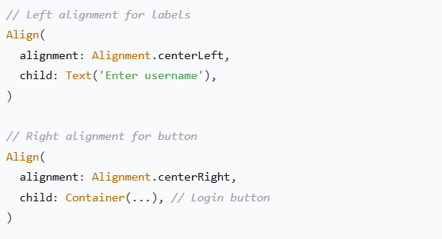

10. PADDING WIDGET
Padding creates breathing room around content. It ensures that text and interactive elements don't touch the edges of the screen, which would look cramped and be harder to interact with.
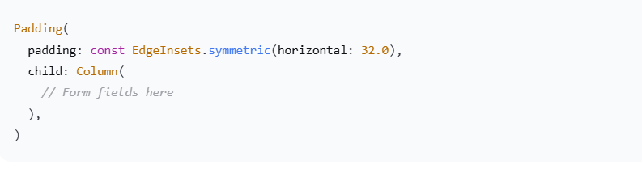

11. SIZEDBOX WIDGET
SizedBox is the spacing workhorse of Flutter layouts. When given a height, it creates a fixed vertical gap between widgets. Different spacing values create visual hierarchy and guide the user's eye through the interface.
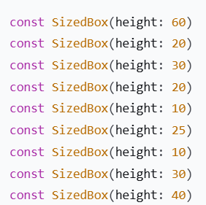

12. BOXDECORATION WIDGET
BoxDecoration is the styling powerhouse that transforms plain containers into visually appealing UI elements. It can add background colors, gradients, borders, rounded corners, and shadows - all the visual effects that make modern UI designs attractive.
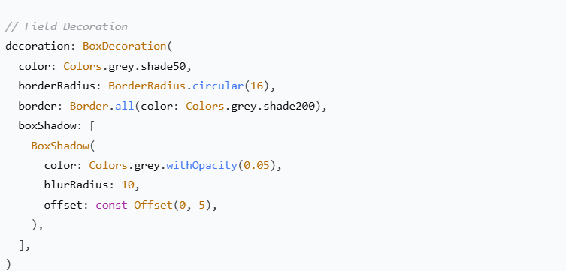
Those are the most used widgets explained above summarly and the screenshots of the codes that show how and where they were applied in this work

